Project Design Phase-I
Solution Architecture

Date | 19 September 2026
Team ID | PNT2022TMIDxxxxxx
Project Name | Global EV Market Intelligence Dashboard
Maximum Marks | 4 Marks

Solution Architecture:
Solution architecture is a complex process – with many sub-processes – that bridges the gap between business problems and technology solutions. Its goals are to:
- Find the best tech solution to solve existing business problems.
- Describe the structure, characteristics, behavior, and other aspects of the software to project stakeholders.
- Define features, development phases, and solution requirements.
- Provide specifications according to which the solution is defined, managed, and delivered.

Sample Solution Architecture Diagram:
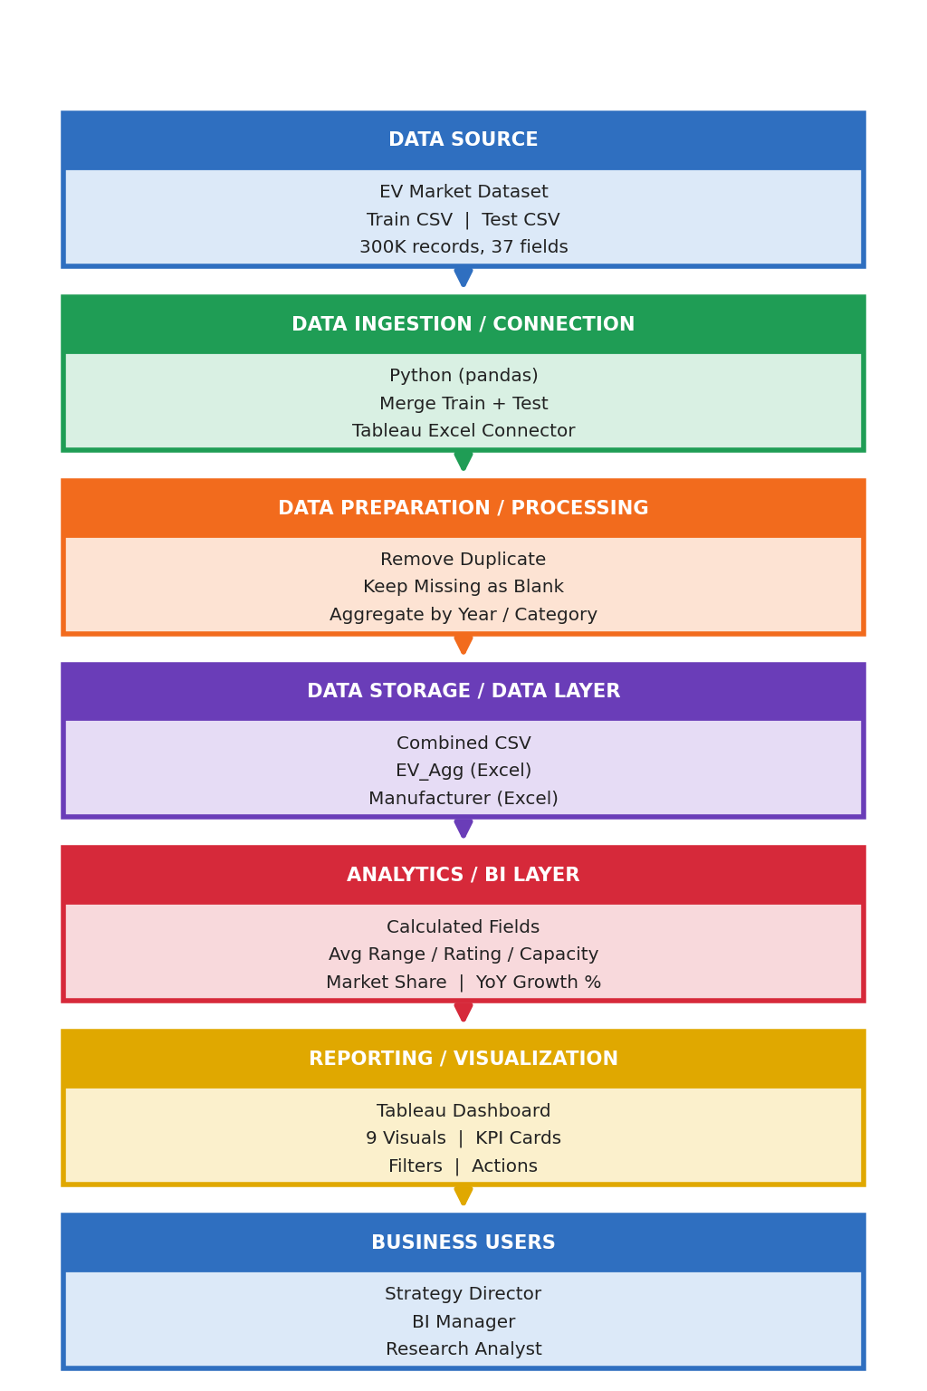

Component Description Table
Component Name | Description / Role in Architecture | Technology Used
Data Source | EV market train and test CSV files (about 300K records, 37 fields) that provide the raw input data. | CSV files
Data Ingestion / Connection | Loads and merges the train and test files and connects Tableau to the prepared Excel extract. | Python (pandas), Tableau Excel connector
Data Preparation / Processing | Removes the duplicate record, keeps missing values as blanks, and aggregates the data by year, category, battery type, country and region. | Python (pandas)
Data Storage / Data Layer | Stores the combined dataset and the aggregated extract (EV_Agg and Manufacturer sheets). | CSV, Excel (.xlsx)
Analytics / BI Layer | Calculates average range, rating and capacity, market share and year-over-year growth. | Tableau calculated fields
Reporting / Visualization | Presents 9 visuals and KPI cards with filters and click-to-filter actions on one dashboard. | Tableau Desktop
Business Users | Strategy Director, BI Manager and Research Analyst use the dashboard for decisions. | Tableau dashboard (workbook, image or PDF export)

